Prairie Link Cheat Sheet
- Enable PrairieLink in Prairie Config Utility under the Misc Tab
- Open Prairie View
- Start COM client (e.g. MATLAB)
- In MATLAB, in order to connect to the COM Server, type the following into the command window:
pl = actxserver('PrairieLink.ImageObject')
If successful, pl should now be a reference to the COM object and the Command Window should show:
pl =
COM.PrairieLink_ImageObject
- We now need to specify which MATLAB program we want to handle the “Image Updated” event from the COM Server. To do this, first change the Matlab current directory to the directory where this file is kept. You can either use the MATLAB GUI
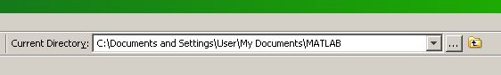
or use UNIX commands for navigation (i.e. cd, ls, pwd)

- Once in the correct directory, register the event to the MATLAB handler program by typing the following into the command window (note the space between “Image Updated” and “NewPVImageHandler”):

pl.registerevent({'ImageUpdated' 'NewPVImageHandler'})

- You can now request images by typing:
pl.RequestImage()
with the request handled by NewPVImageHandler.m

- Now you can run the script “requestingImages.m” to continuously request images. The RequestImage() command is in a for loop, so you can change the number of iterations and the time to wait in between each request.
